Mycenaean Artwork
Student’s Name
Institution
Date

Mycenaean Artwork
According to the artwork of masks and daggers done by Schliemann, the place of origin that happened to be Greece was provided. The information was useful in enabling a clear understanding of the birth of masks and daggers. Additionally, the description of costumes was done to help in showing the features used in making the artworks. The use of metal and gold materials enables people to understand the story of masks and daggers (Sears, 2019). The covers form a significant form of monuments that allowed the identity of a person gets concealed. Discussion of the costumes and knives were used to be worn by people during festivals in which character was to get hidden. The Mycenaean masks get developed between the period of 1600-1500 BC. Various types of covers get constructed in ancient times with the nature of the event that was to take place (Sears, 2019). The maturity of men's faces gets depicted through the use of masks that made identification of youths and mature people to be confirmed. Costumes were also worn by the king during ancient times, as described by Schliemann. The human face gets created through the use of masks according to the nature of their portrait size.
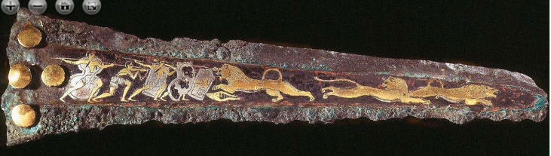
Dagger Lion hunt
Mathew Rahimi
I support your opinion concerning Lion Gate usefulness in creating an understanding of the Mycenaean work. The fascinating form of ancient architecture has got discussed in a systematic manner that allows anybody to understand the historical activity. Also, adequate details on the description of the Lion Gate assist in creating full understanding. Exemplary work done!
Min Hyeok Kong
On the other hand, I agree with description made on the Male Harp Player in a proper form that involved its time and place of origin. The period of birth was also provided hence creating an understanding of the artwork (Sears, 2019). In-depth information regarding materials used in making the Male Harp Player that ensured adequate information is determined. Good work!

References
Sears, M. A. (2019). Understanding Greek Warfare. Routledge.

